**Exploring the Networks**

**IT-307**

**Lab File**

Submitted to

**AMITY UNIVERSITY UTTAR PRADESH**



**In partial fulfilment of the requirements for the award of the degree of**

**Bachelor of technology**

**In**

Computer Science & Engineering

By

Devanshu Mittal

5CSE2Y

(A2305220128)

Submitted to:

Dr. Shipra Shukla

**DEPARTMENT OF AMITY SCHOOL OF ENGINEERING**

**AMITY UNIVERSITY UTTAR PARDESH**

**NOIDA (U.P.)**

**INDEX**

|  |  |  |  |
| --- | --- | --- | --- |
| **S. No.** | **Title** | **Date** | **Sign.** |
|  |  |  |  |
|  |  |  |  |
|  |  |  |  |
|  |  |  |  |
|  |  |  |  |
|  |  |  |  |
|  |  |  |  |
|  |  |  |  |
|  |  |  |  |
|  |  |  |  |
|  |  |  |  |
|  |  |  |  |
|  |  |  |  |
|  |  |  |  |
|  |  |  |  |
|  |  |  |  |
|  |  |  |  |

**Lab-1**

**Aim:** To describe some of troubleshooting commands.

**Commands:**

**ping** A ping (Packet Internet or Inter-Network Groper) is a basic [Internet](https://www.techtarget.com/whatis/definition/Internet) program that allows a user to test and verify if a particular destination [IP address](https://www.techtarget.com/whatis/definition/IP-address) exists and can accept requests in computer network administration.

**-t** Ping the specified host until stopped using Ctrl + C.

**time** shows the time taken by packet to be received by the user.

**TTL** is the total time to live for packet. The packet is informative only for this much intermediary devices.

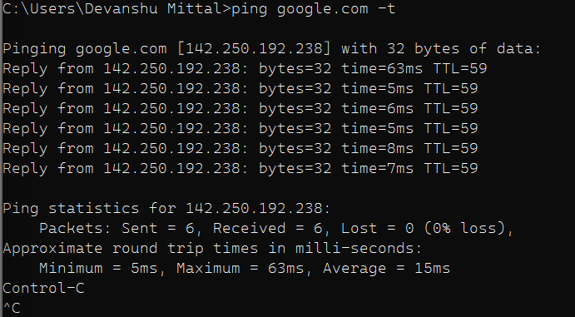

**ipconfig** Displays all current TCP/IP network configuration values and refreshes Dynamic Host Configuration Protocol (DHCP) and Domain Name System (DNS) settings. Used without parameters, ipconfig displays Internet Protocol version 4 (IPv4) and IPv6 addresses, subnet mask, and default gateway for all adapters.

**Default Gateway** is the last device’s IP address through which the system is connected to the outer network.

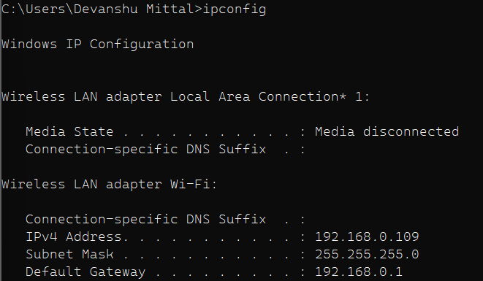

**finger** A command-line utility known as “finger” is used to display all available information about the system's user.

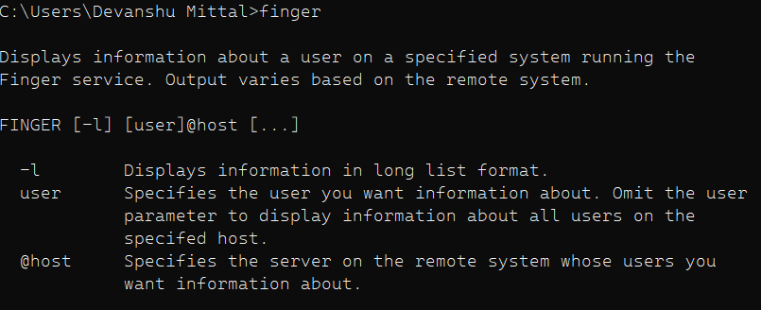

**tracert** A traceroute plays a different role than other diagnostic tools, such as packet capture, which analyzes data.

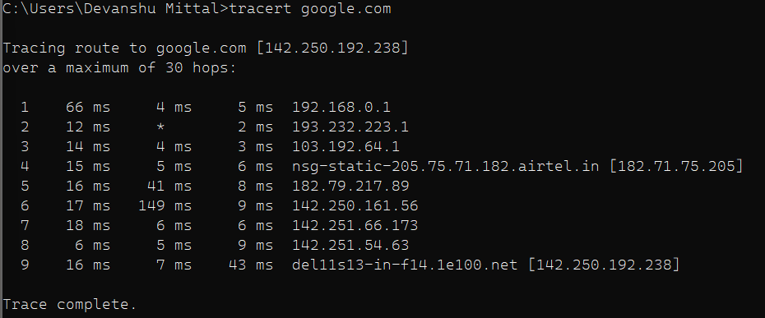

**pathping** It combines the functionality of ping and tracert. It is used to locate spots that have network latency and network loss.

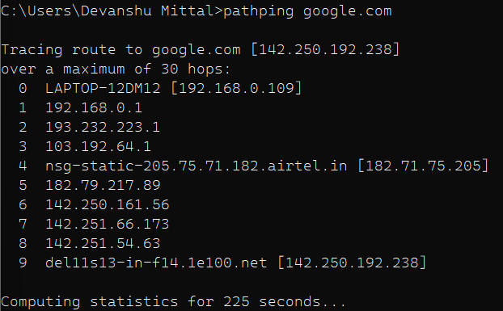

**arp** Address Resolution Protocol (ARP) is a procedure for mapping a dynamic IP address to a permanent physical machine address in a local area network (LAN).

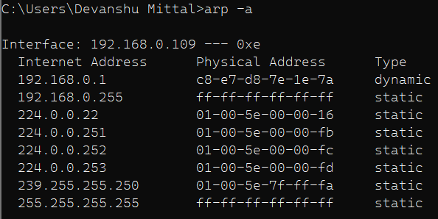

**hostname** The identity of a host/website is identified by its name.



**whoami** It shows the effective user ID.



**Lab-2**

**Aim:** To construct five different topologies and configure them.

**Network Topologies:**

**Star Topology**

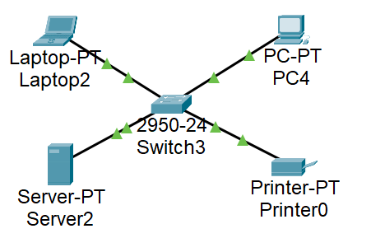 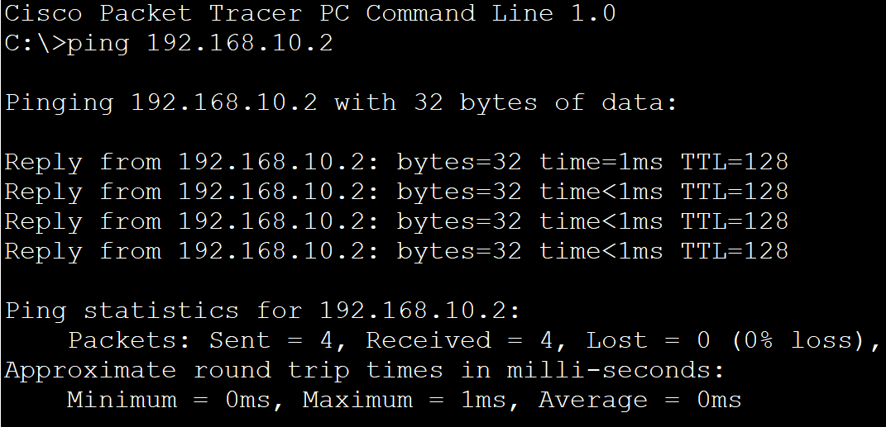

**Mesh Topology**

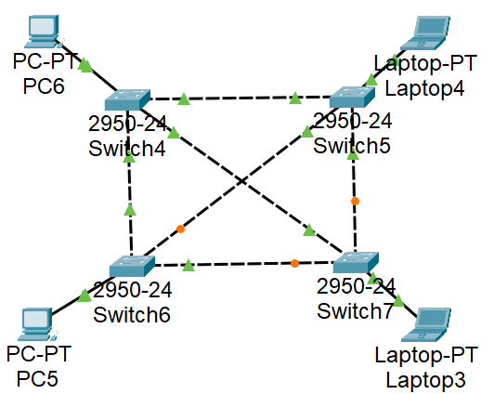 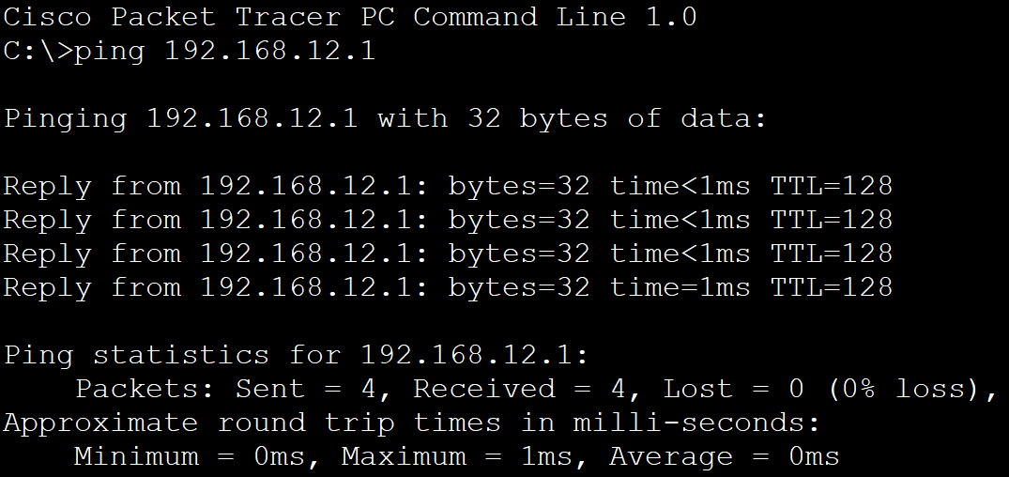

**Ring Topology**

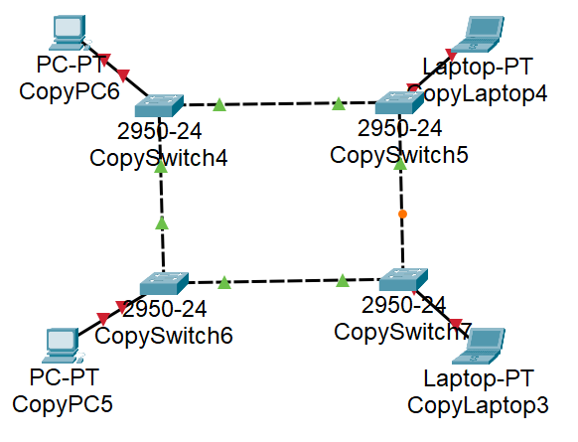 

**Bus Topology**

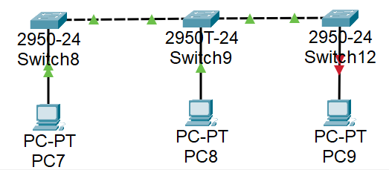



**Hybrid Topology**

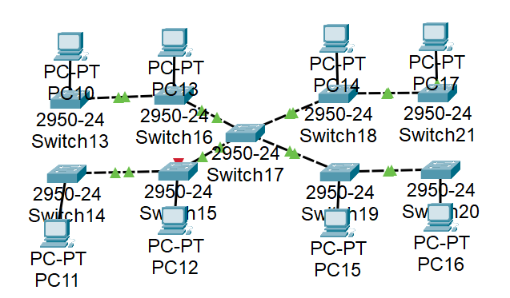



**Lab-3**

**Aim:** Configuring the switches in a network.

**Network Topology:**

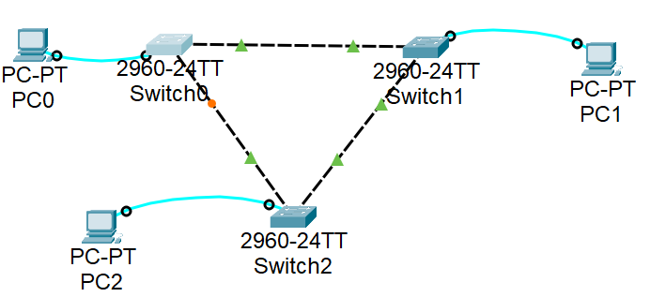

**Configuration and Commands:**

Switch>enable

Switch#configure terminal

Enter configuration commands, one per line. End with CNTL/Z.

Switch(config)#hostname sw-Floor-1

sw-Floor-1(config)#line console 0

sw-Floor-1(config-line)#password cisco

sw-Floor-1(config-line)#login

sw-Floor-1(config-line)#end

sw-Floor-1#

%SYS-5-CONFIG_I: Configured from console by console

sw-Floor-1#configure terminal

Enter configuration commands, one per line. End with CNTL/Z.

sw-Floor-1(config)#enable secret class

sw-Floor-1(config)#exit

sw-Floor-1#

%SYS-5-CONFIG_I: Configured from console by console

sw-Floor-1#configure terminal

Enter configuration commands, one per line. End with CNTL/Z.

sw-Floor-1(config)#line vty 0 15

sw-Floor-1(config-line)#password cisco

sw-Floor-1(config-line)#login

sw-Floor-1(config-line)#end

sw-Floor-1#

%SYS-5-CONFIG_I: Configured from console by console

sw-Floor-1#configure terminal

Enter configuration commands, one per line. End with CNTL/Z.

sw-Floor-1(config)#service password-encryption

sw-Floor-1(config)#exit

sw-Floor-1#

%SYS-5-CONFIG_I: Configured from console by console

sw-Floor-1#show running-config

Building configuration...

Current configuration : 1212 bytes

!

version 15.0

no service timestamps log datetime msec

no service timestamps debug datetime msec

service password-encryption

!

hostname sw-Floor-1

!

enable secret 5 $1$mERr$9cTjUIEqNGurQiFU.ZeCi1

!

!

!

!

!

!

spanning-tree mode pvst

spanning-tree extend system-id

!

interface FastEthernet0/1

!

interface FastEthernet0/2

!

interface FastEthernet0/3

!

interface FastEthernet0/4

!

interface FastEthernet0/5

!

interface FastEthernet0/6

!

interface FastEthernet0/7

!

interface FastEthernet0/8

!

interface FastEthernet0/9

!

interface FastEthernet0/22

!

interface FastEthernet0/23

!

interface FastEthernet0/24

!

interface GigabitEthernet0/1

!

interface GigabitEthernet0/2

!

interface Vlan1

no ip address

shutdown

!

line con 0

password 7 0822455D0A16

login

!

line vty 0 4

password 7 0822455D0A16

login

line vty 5 15

password 7 0822455D0A16

login

!

end

sw-Floor-1#configure terminal

Enter configuration commands, one per line. End with CNTL/Z.

sw-Floor-1(config)#banner motd #Authorize Access only!#

sw-Floor-1(config)#copy run start

**Lab-4**

**Aim:** To configure VLAN in a network.

**Theory:** VLAN is a group of end stations in a switched network that is logically segmented by function or application, without regard to the physical locations of the users.

**Topology:**

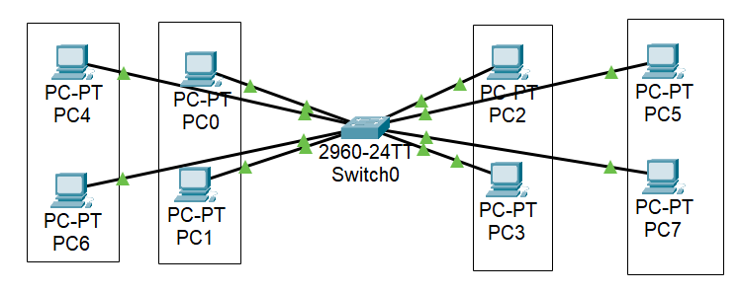

**Configuration and Commands:**

Switch>en

Switch#conf t

Enter configuration commands, one per line. End with CNTL/Z.

Switch(config)#vlan 10

Switch(config-vlan)#name green

Switch(config-vlan)#vlan 20

Switch(config-vlan)#name orange

Switch(config-vlan)#vlan 30

Switch(config-vlan)#name pink

Switch(config-vlan)#vlan 40

Switch(config-vlan)#name blue

Switch(config-vlan)#exit

Switch(config)#interface range FastEthernet 0/1-5

Switch(config-if-range)#switchport mode access

Switch(config-if-range)#switchport access vlan 10

Switch(config-if-range)#interface range FastEthernet 0/6-10

Switch(config-if-range)#switchport mode access

Switch(config-if-range)#switchport access vlan 20

Switch(config-if-range)#interface range FastEthernet 0/11-15

Switch(config-if-range)#switchport mode access

Switch(config-if-range)#switchport access vlan 30

Switch(config-if-range)#interface range FastEthernet 0/16-20

Switch(config-if-range)#switchport mode access

Switch(config-if-range)#switchport access vlan 40

Switch(config-if-range)#exit

**Lab-5**

**Aim:** To configure the router and test the connectivity.

**Theory:** Router is an intelligent device which forwards the data between LANs and can also process the data.

**Topology:**

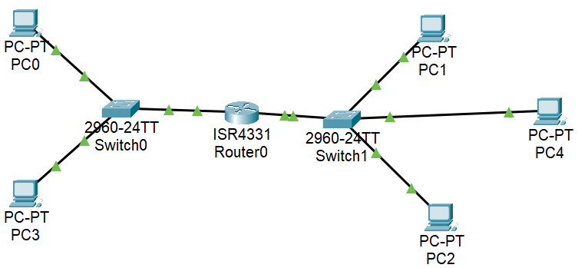

**Configuration and commands:**

Router>en

Router#conf t

Enter configuration commands, one per line. End with CNTL/Z.

Router(config)#hostname R1

R1(config)#interface g0/0/0

R1(config-if)#ip address 192.168.10.2 255.255.255.0

R1(config-if)#no shutdown

R1(config-if)#interface g0/0/1

R1(config-if)#ip address 192.168.11.2 255.255.255.0

R1(config-if)#no shutdown

R1(config-if)#interface loopback 0

R1(config-if)#

%LINK-5-CHANGED: Interface Loopback0, changed state to up

%LINEPROTO-5-UPDOWN: Line protocol on Interface Loopback0, changed state to up

R1(config-if)#ip address 192.168.12.2 255.255.255.0

R1(config-if)#no shutdown

R1(config-if)#interface loopback 0

R1(config-if)#ip address 192.168.13.2 255.255.255.0

R1(config-if)#end

R1#

%SYS-5-CONFIG_I: Configured from console by console

R1#copy running-config startup-config

Destination filename [startup-config]?

Building configuration...

[OK]

**Testing the connectivity:**

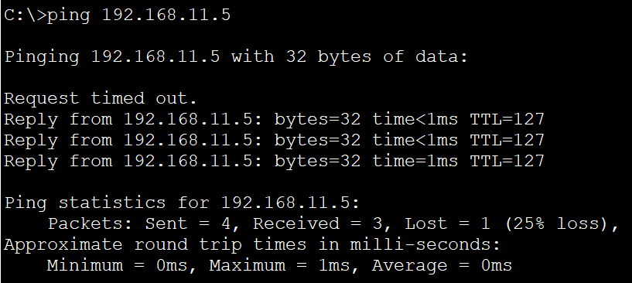

**Lab-6**

**Aim:** To configure VLAN in router using 802.1Q

**Theory:** The IEEE.802.1Q protocol is used to interconnect multiple switches and routers and for defining VLAN topologies.

**Topology:**

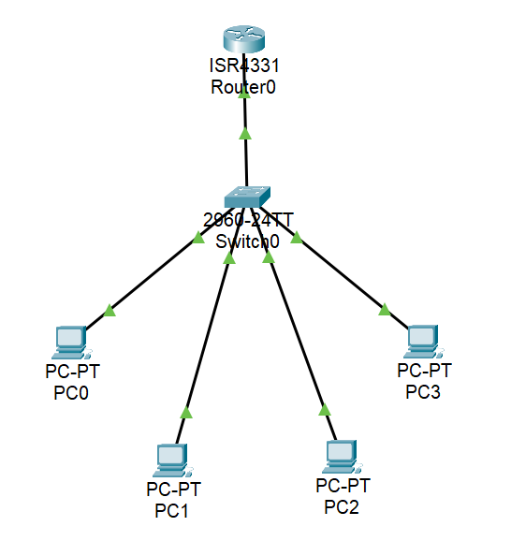

**Commands:**

Router>en

Router#conf t

Enter configuration commands, one per line. End with CNTL/Z.

Router(config)#interface g0/0/0

Router(config-if)#no ip address

Router(config-if)#no shutdown

Router(config-if)#exit

Router(config)#interface g0/0/0.10

Router(config-subif)#

%LINK-5-CHANGED: Interface GigabitEthernet0/0/0.10, changed state to up

%LINEPROTO-5-UPDOWN: Line protocol on Interface GigabitEthernet0/0/0.10, changed state to up

Router(config-subif)#encapsulation dot1Q 10

Router(config-subif)#ip address 10.0.0.1 255.0.0.0

Router(config-subif)#exit

Router(config)#interface g0/0/0.20

Router(config-subif)#

%LINK-5-CHANGED: Interface GigabitEthernet0/0/0.20, changed state to up

%LINEPROTO-5-UPDOWN: Line protocol on Interface GigabitEthernet0/0/0.20, changed state to up

Router(config-subif)#encapsulation dot1Q 20

Router(config-subif)#ip address 20.0.0.1 255.0.0.0

Router(config-subif)#exit

Router(config)#

Router#

%SYS-5-CONFIG_I: Configured from console by console

**Lab-7**

**Aim:** Configuring router using IPv6 address.

**Theory:** IPv6 address consist of 128 bits. It is compacted to 32 hexadecimal digits. 4 such digits are grouped and separated by a colon.

**Topology:**

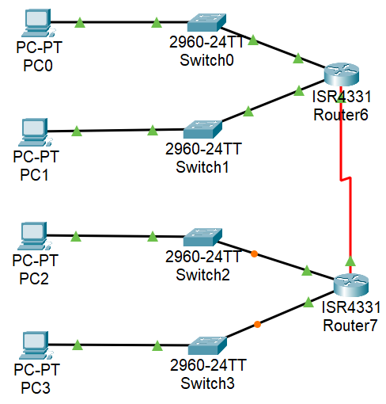

**Commands:**

Router>en

Router#conf t

Enter configuration commands, one per line. End with CNTL/Z.

Router(config)#interface gigabitethernet 0/0/0

Router(config-if)#ipv6 address 2001:db8:abcd:a::1/64

Router(config-if)#no shutdown

Router(config-if)#

%LINK-5-CHANGED: Interface GigabitEthernet0/0/0, changed state to up

Router(config-if)#exit

Router(config)#interface gigabitethernet 0/0/1

Router(config-if)#ipv6 address 2001:db8:abcd:b::1/64

Router(config-if)#no shutdown

Router(config-if)#

%LINK-5-CHANGED: Interface GigabitEthernet0/0/1, changed state to up

Router(config-if)#exit

Router(config)#interface serial 0/1/0

%LINEPROTO-5-UPDOWN: Line protocol on Interface GigabitEthernet0/0/0, changed state to up

%LINEPROTO-5-UPDOWN: Line protocol on Interface GigabitEthernet0/0/1, changed state to up

Router(config-if)#ipv6 address 2001:db8:acad:5::1/64

Router(config-if)#no shutdown

%LINK-5-CHANGED: Interface Serial0/1/0, changed state to down

Router(config-if)#exit

Router(config)#

%LINK-5-CHANGED: Interface Serial0/1/0, changed state to up

%LINEPROTO-5-UPDOWN: Line protocol on Interface Serial0/1/0, changed state to up

**Lab-8**

**Aim:** Configuring router using static IPv4 address.

**Theory:** In static routing the router must be interconnected by a serial connection. Later, the connections needed to be routed.

**Topology:**

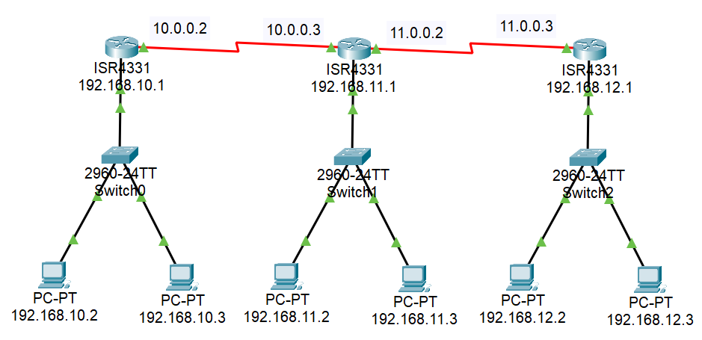

**Commands:**

Router2>en

Router2#conf t

Enter configuration commands, one per line. End with CNTL/Z.

Router2(config)# interface gigabitethernet 0/0/0

Router2(config-if)#ip address 192.168.11.1 255.255.255.0

Router2(config-if)#no shutdown

Router2(config-if)#

%LINK-5-CHANGED: Interface GigabitEthernet0/0/0, changed state to up

Router2(config-if)#exit

Router2(config)#interface serial 0/1/0

Router2(config-if)#ip address 10.0.0.3 255.0.0.0

Router2(config-if)#no shutdown

%LINK-5-CHANGED: Interface Serial0/1/0, changed state to down

Router2(config-if)#exit

Router2(config)#

%LINK-5-CHANGED: Interface Serial0/1/0, changed state to up

Router2(config)#interface serial 0/1/1

Router2(config-if)#ip address 11.0.0.2 255.0.0.0

Router2(config-if)#no shutdown

%LINK-5-CHANGED: Interface Serial0/1/1, changed state to down

Router2(config-if)#exit

Router2(config)#

%LINK-5-CHANGED: Interface Serial0/1/1, changed state to up

Router2(config)#ip route 192.168.10.0 255.255.255.0 10.0.0.2

Router2(config)#ip route 192.168.12.0 255.255.255.0 11.0.0.3

Router2(config)#ip route 10.0.0.0 255.0.0.0 11.0.0.2

Press RETURN to get started!

**Lab-9**

**Aim:** Configuring DHCP,DNS,WEB server.

**Theory:** In static routing the router must be interconnected by a serial connection. Later, the connections needed to be routed.

**Topology:**

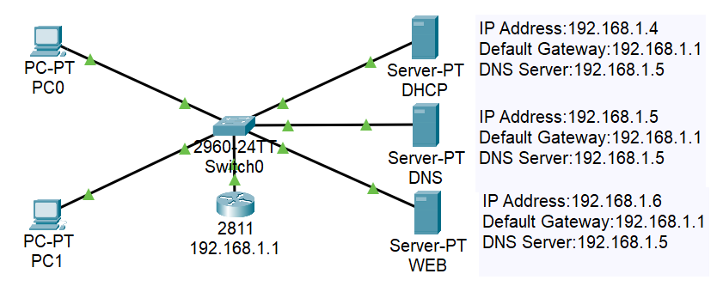

**Commands:**

Router>en

Router#conf t

Enter configuration commands, one per line. End with CNTL/Z.

Router(config)#int fa0/0

Router(config-if)#ip add 192.168.1.1 255.255.255.0

Router(config-if)#no shutdown

Router(config-if)#

%LINK-5-CHANGED: Interface FastEthernet0/0, changed state to up

%LINEPROTO-5-UPDOWN: Line protocol on Interface FastEthernet0/0, changed state to up

Router(config-if)#exit

Router(config)#ip dhcp pool MY_LAN

Router(dhcp-config)#network 192.168.1.0 255.255.255.0

Router(dhcp-config)#default-router 192.168.1.1

Router(dhcp-config)#dns-server 192.168.1.10

Router(dhcp-config)#exit

Router(config)#ip dhcp excluded-address 192.168.1.1 192.168.1.10

Router(config)#

**Output:**

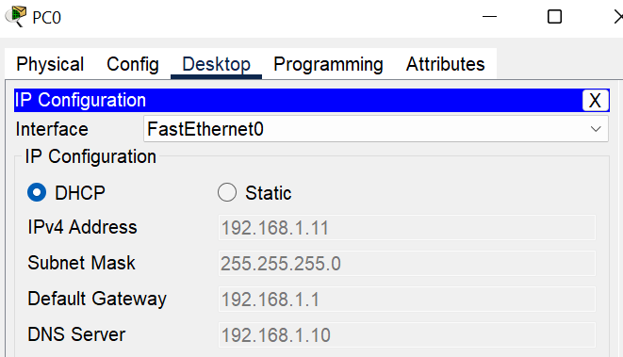

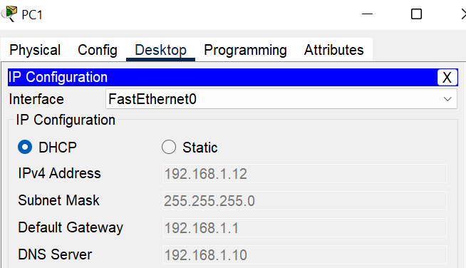

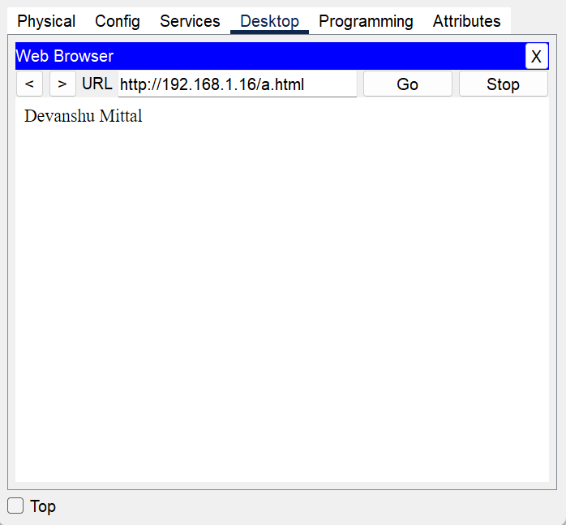

**Lab-10**

**Aim:** Identify TCP,UDP header fields and operation using a Wireshark FTP,TFTP session capture.

**Theory:** Transmission Control Protocol (TCP) is a standard that defines how to establish and maintain a network conversation by which applications can exchange data. User Datagram Protocol (UDP) is a Transport Layer protocol. UDP is a part of the Internet Protocol suite, referred to as UDP/IP suite. FTP (File Transfer Protocol) is a network protocol for transmitting files between computers over Transmission Control Protocol/Internet Protocol (TCP/IP). Trivial File Transfer Protocol (TFTP) is a simple lockstep File Transfer Protocol which allows a client to get a file from or put a file onto a remote host.

**UDP:**

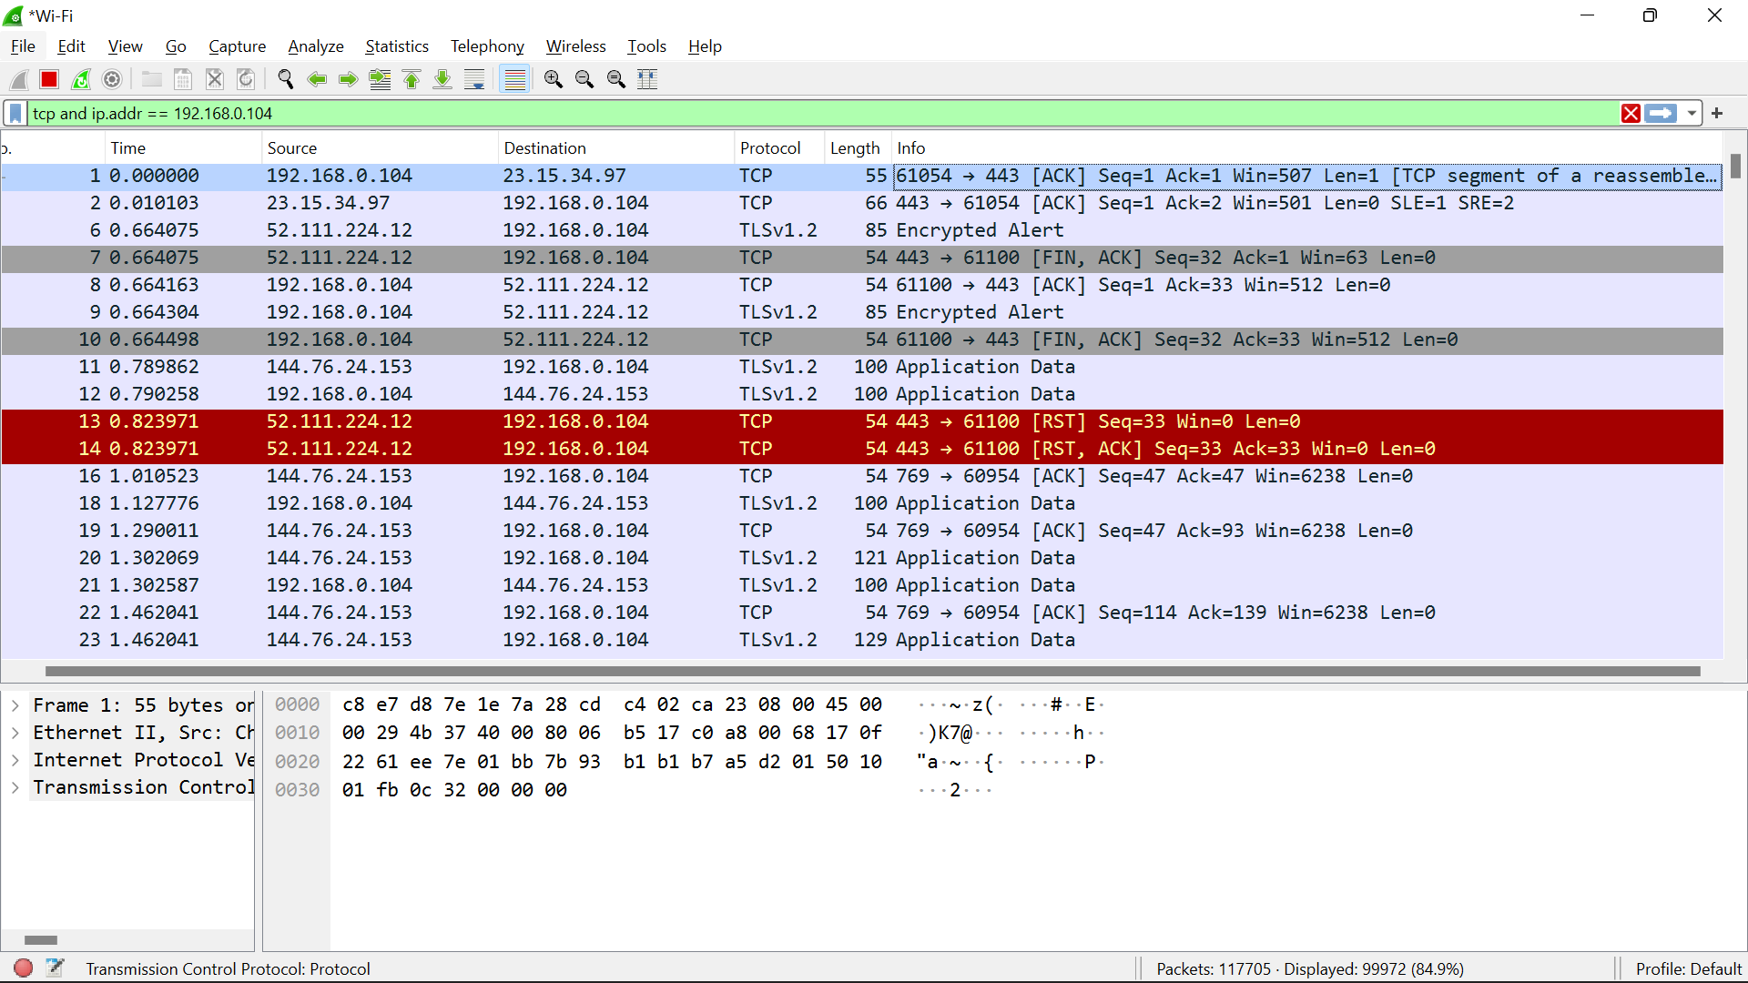

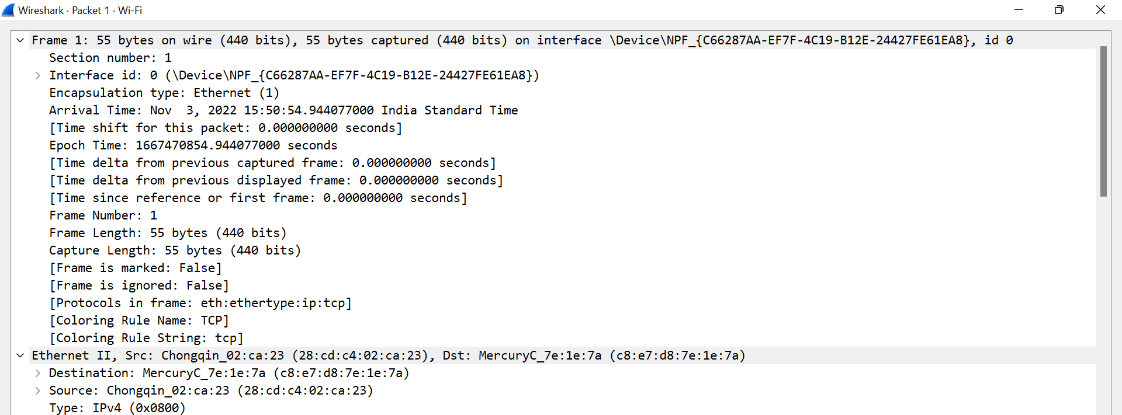

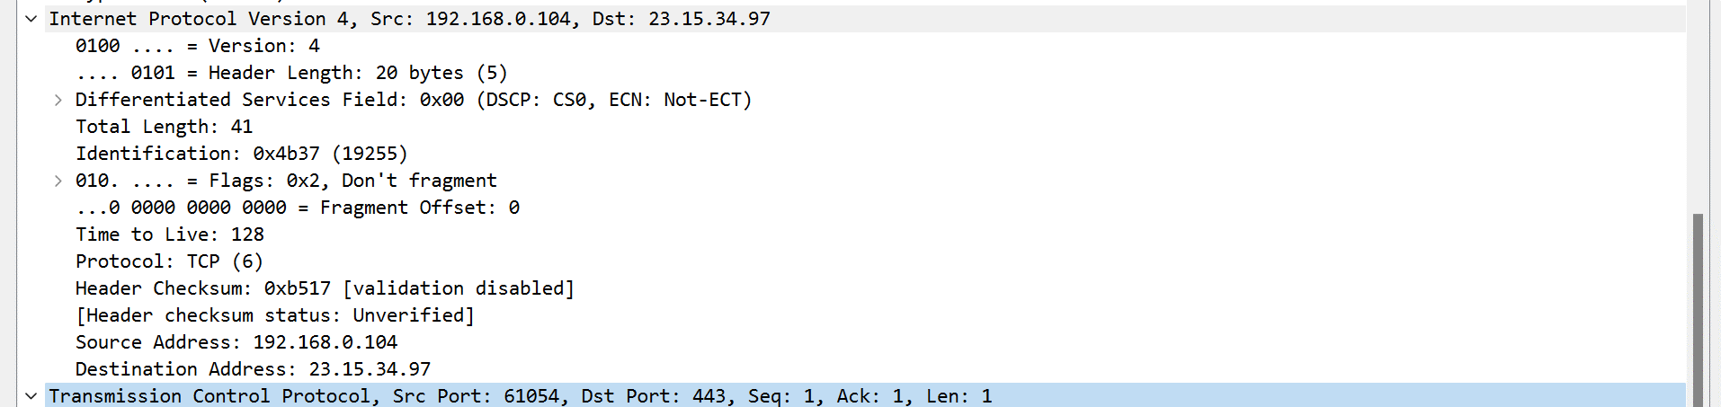

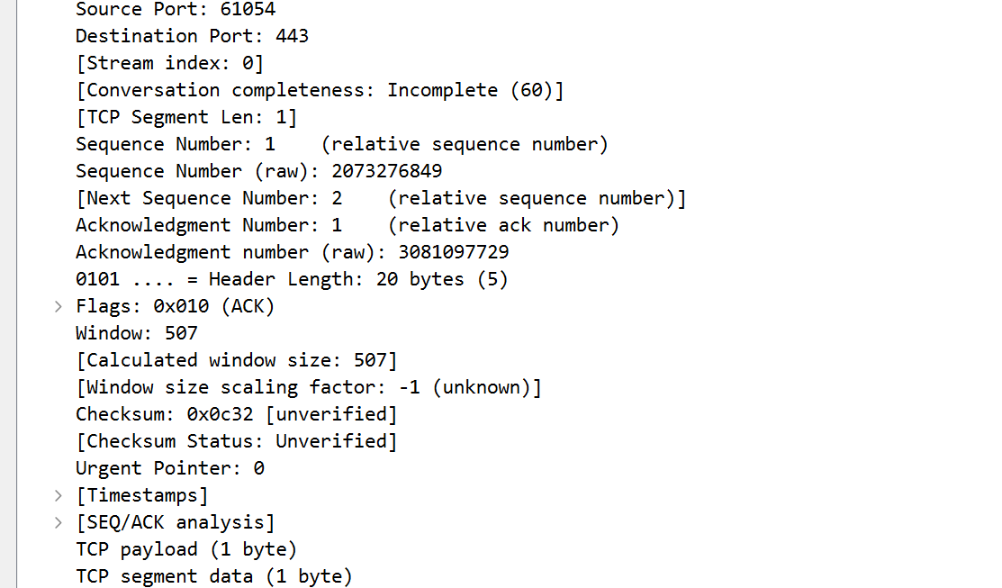

**TCP:**

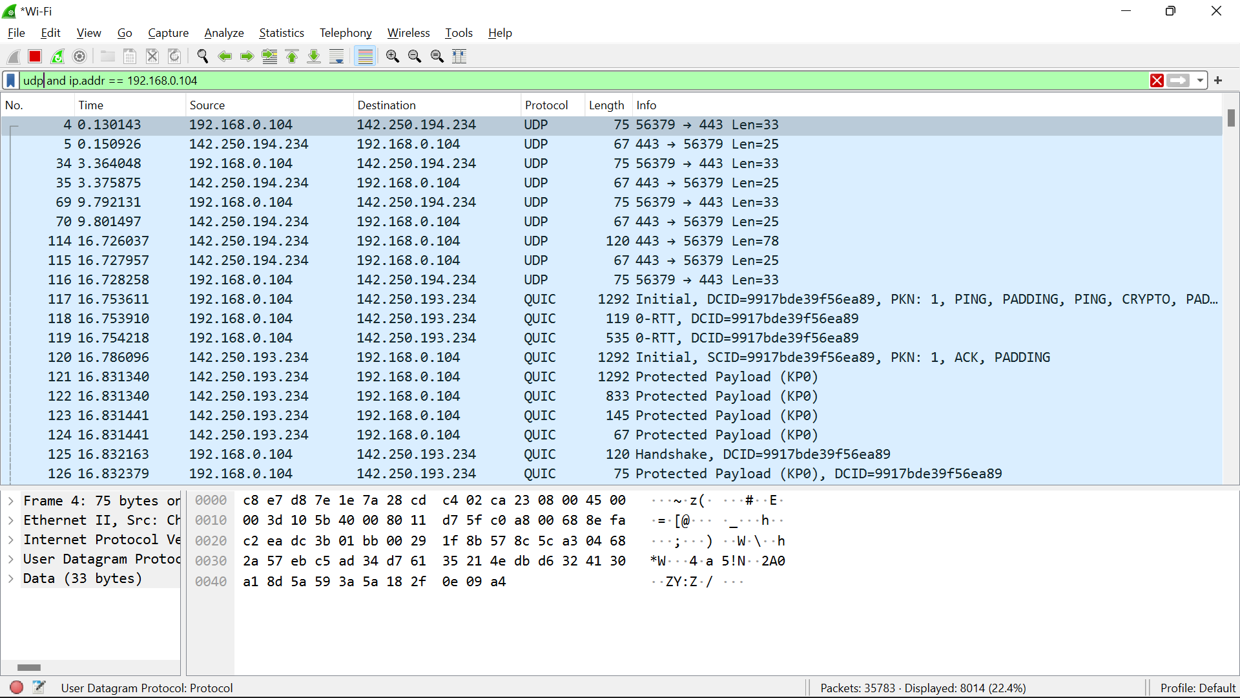

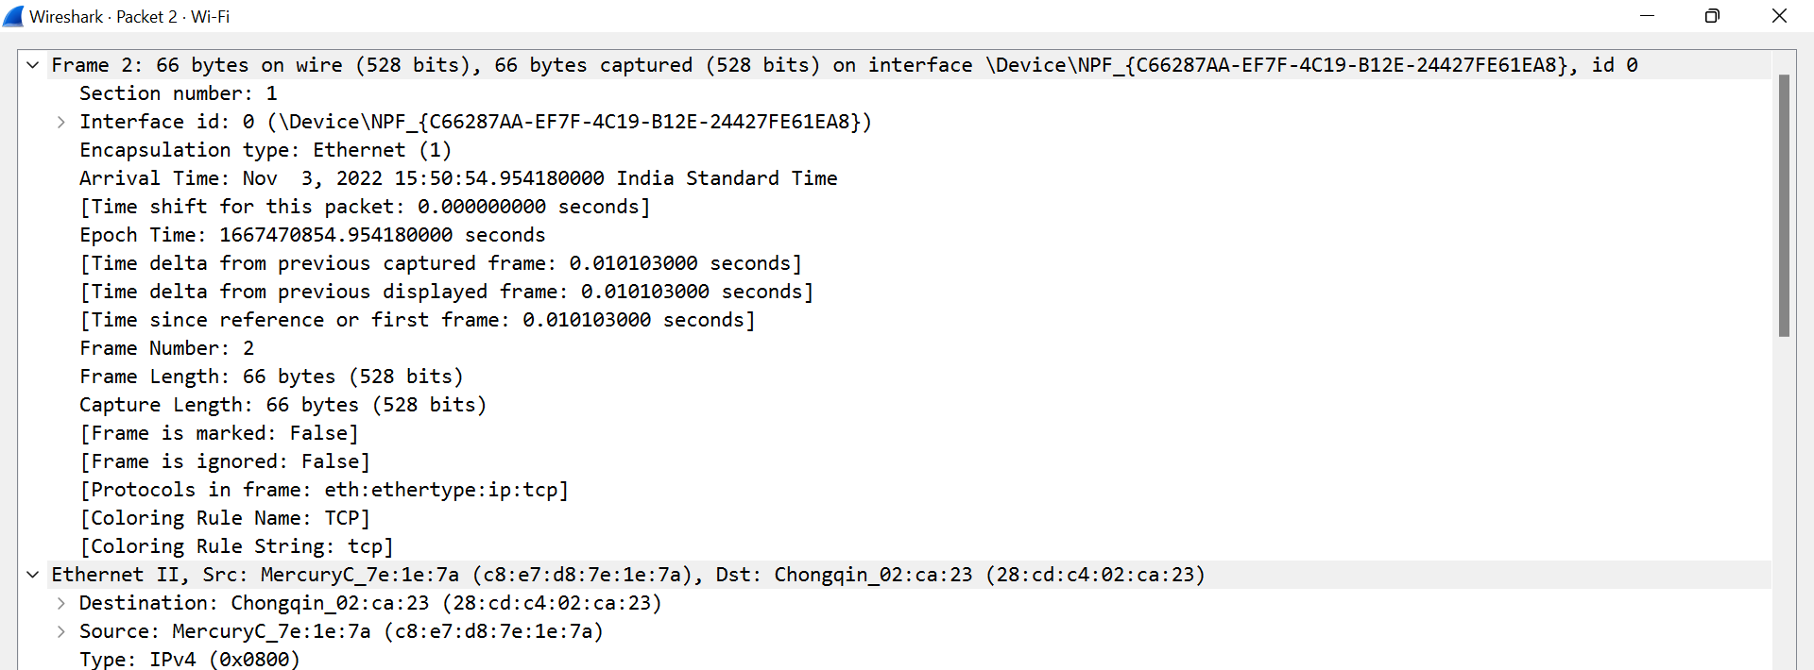 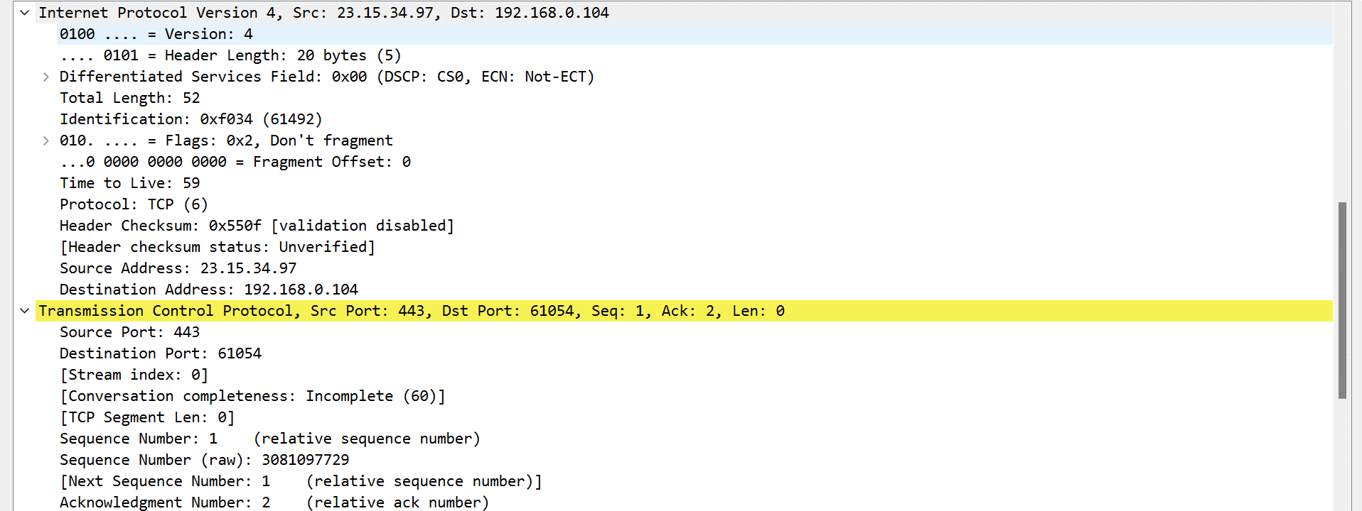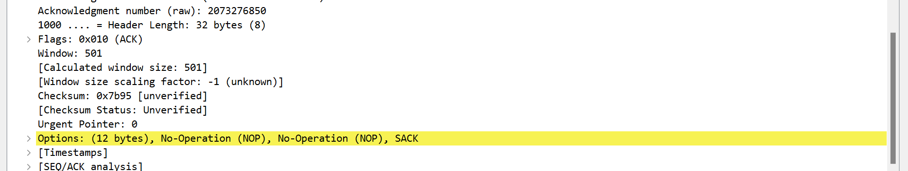

|  |  |  |  |
| --- | --- | --- | --- |
| Internal Assessment (Mandatory Experiment) Sheet for Lab Experiment  Department of Computer Science & Engineering  Amity University, Noida (UP) | | | |
| Programme | B. Tech CSE | Course Name | Exploring the Networks |
| Course Code | [IT307] | Semester | 5 |
| Student Name | Devanshu Mittal | Enrollment No. | A2305220128 |
| Marking Criteria | | | |
| Criteria | Total Marks | Marks Obtained | Comments |
| Concept (A) | 2 |  |  |
| Implementation (B) | 2 |  |  |
| Performance (C) | 2 |  |  |
| Total | 6 |  |  |